Curriculum Vitae
 |  | 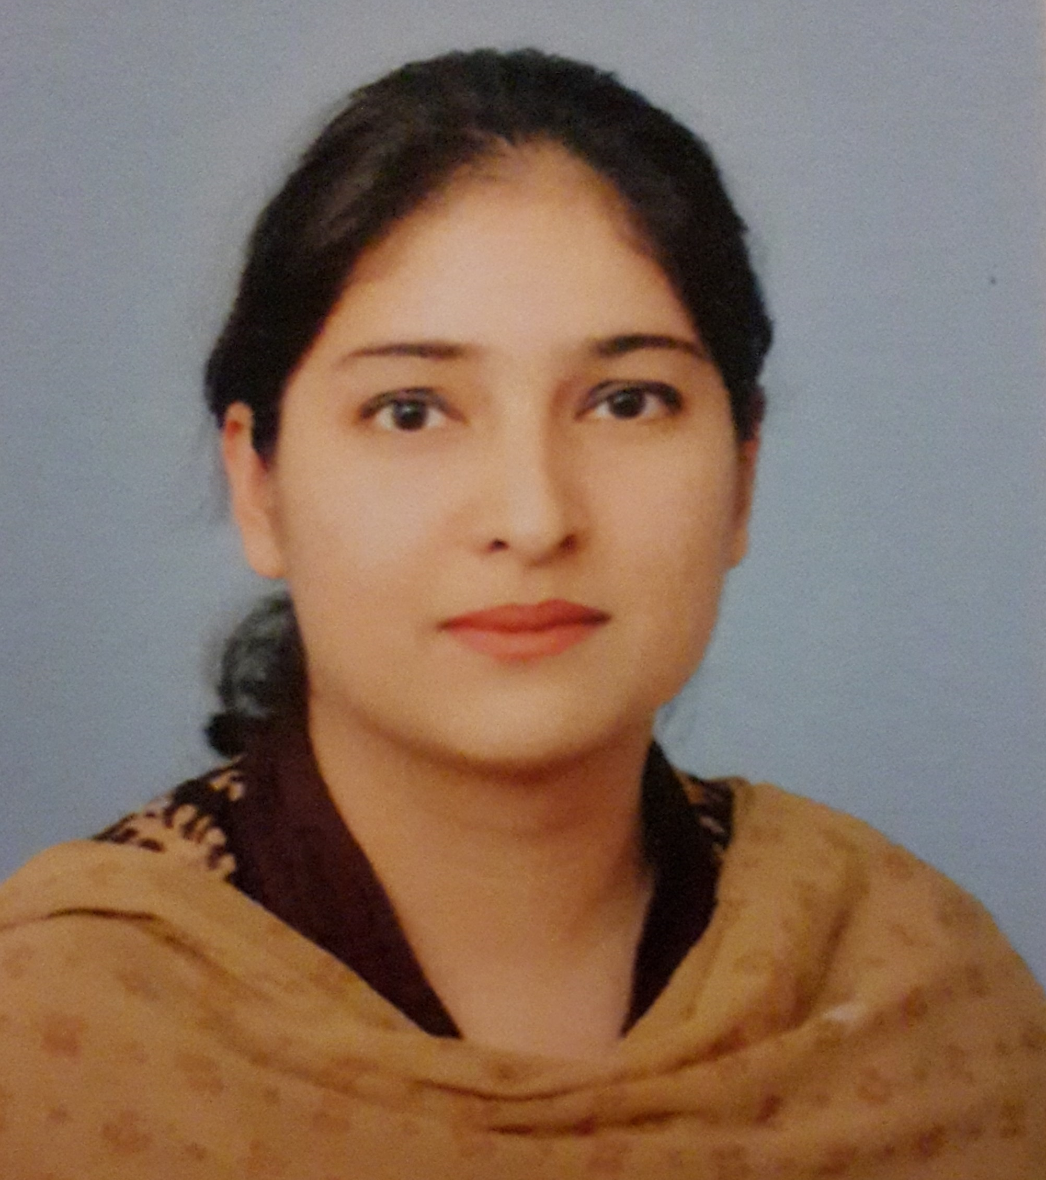
Personal information
First name(s) / Surname(s) |  | Hira Noman
Address |  | Department of Software Engineering, Mehran UET  76062 Jamshoro (Pakistan)
Telephone(s) |  | +92 222772253 ex. 6907
Fax(es) |  | ----
E-mail(s) |  | Hira.noman@faculty.muet.edu.pk
Nationality |  | Pakistani
Date of birth |  | 02 December 1986
Gender |  | Female
Work experience
Dates  Occupation or position held  Main activities and responsibilities  Name and address of employer  Type of business or sector  Dates |  | 08 November 2016 - till today  Assistant Professor  Teaching undergraduate engineering students  Doing research in Software engineering field  Mehran University of Engineering and Technology  76062 Jamshoro (Pakistan)  Education  03 June 2011 - 7 November 2016
Occupation or position held |  | Lecturer
Main activities and responsibilities |  | Teaching undergraduate engineering students  Doing research in Software engineering field
Name and address of employer |  | Mehran University of Engineering and Technology  76062 Jamshoro (Pakistan)
Type of business or sector |  | Education
Dates |  | 16 July 2010 - 02 June 2011 (10 Months 17 Days)
Occupation or position held |  | Lecturer (On Contract)
Main activities and responsibilities |  | Teaching Software engineering subjects to undergraduate engineering students
Name and address of employer |  | Mehran University of Engineering and Technology  76062 Jamshoro (Pakistan)
Type of business or sector |  | Education
Education
Dates |  | 01 January 2007 - 30 March 2009
Title of qualification awarded |  | Masters of Engineering (3.77 CGPA)
Name and type of organisation providing education and training |  | Mehran UET (Public sector university)  76062 Jamshoro (Pakistan)
Dates |  | 01 January 2002 - 04 January 2006
Title of qualification awarded |  | Bachelors of Engineering (83.76%)
Name and type of organisation providing education and training |  | Mehran UET (Public sector university)  76062 Jamshro (Pakistan)
Personal skills and Competences
Mother tongue(s) |  | Sindhi
Other language(s)
Self-assessment |  |  | Understanding |  |  |  | Speaking |  |  |  | W r i t i n g
European level (*) |  |  | Listening |  | Reading |  | Spoken interaction |  | Spoken production
English |  |  | C1 | Proficient user | C1 | Proficient user | C1 | Proficient user | C1 | Proficient user | C1 | Proficient user
Urdu |  |  | C2 | Proficient user | C2 | Proficient user | C2 | Proficient user | C2 | Proficient user | C2 | Proficient user
Social skills and competences |  | Good ability to adapt to multicultural environments.  Good communication skills gained through public sector jobs
Organisational skills and competences |  | skilled to work in team, manage team as lead or work as member.  Remained Group lead in academic projects.
Computer skills and competences |  | - Good command of Office Automation Tools (Word™, Excel™ and PowerPoint™)  - Good skills in programming languages (C, C++, Java, Python)  - Good command of Microsoft Access, MySQL, Oracle Databases  - Good command in using Operating Systems (Microsoft Windows)  - Basic knowledge of graphic design applications (Gimp, PhotoShop™)
Other skills, achievemtns and competences |  | - 3rd Position in B.E (Software Engineering)  - Merit Awards each year during B.E from MUET, Jamshoro  -10th position in H.S.S.C-II from B.I.S.E Hyderabad
Driving licence(s) |  | Car
Additional information  Thesis/Project Supervision  Research Publications |  | - Under-Graduate: Several Undergraduate Dissertations/Projects have been supervisied  International Journal Article  - Shah, S. M. S., Wilson, J., Khalique, V., & Noman, H. (2017). An analysis of RDF view maintenance using Jena. Indian Journal of Science and Technology, 9(48).  National Journal Article  - Noman, H., Nizamani, S., & Shah, S. (2016). An Ontological Specification Of A Computational Cloud. Sindh University Research Journal-SURJ (Science Series), 48(1)  International Conference  - Shah, Syed M. Shehram and Wilson, John and Khalique, Vijdan and Noman, Hira (2017) An analysis of RDF view maintenance using Jena. In: International Conference on Recent Trends in Computer Science and Electronics, 2017-01-02 - 2017-01-03.

