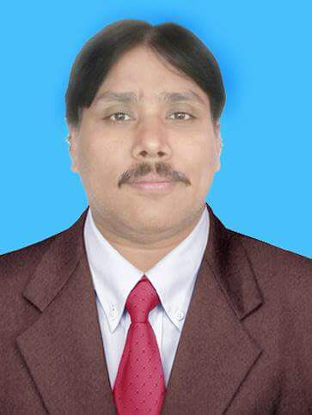
Salahuddin Saddar Mobile: 0334-3261956
Email: Salahuddin.Saddar@faculty.muet,edu.pk
Assistant Professor

Introduction | Salahuddin Saddar has done Master’s degree in Software Engineering from Mehran University of Engineering and Technology, bachelor’s degree in Computer System Engineering g from Mehran University of Engineering and Technology, Pakistan. He is currently working as Assistant Professor at Department of Software Engineering, Mehran UET Pakistan. His research interests are focused in the field of Software Engineering, Communication, HCI and He is a member of Pakistan Engineering Council (PEC).

POSITIONS HELD
Employment | Duration
- Worked as Lab-Lecturer (on Contract) in Department of Computer Systems and Software Engineering Mehran UET Jamshoro from April 2003 to June 2008.  - Worked as Lecturer (Regular)in Department of Computer Systems and Software Engineering Mehran UET Jamshoro from July 2008 to Jan 2011.  - Worked as Assistant Professor in Department of Software Engineering from Feb 2011 to till date. | - 5 year 3 months  - 2 years 5 months  - 7 years 10 months

EDUCATION DETAILS
ME- Software Engineering | Master of Engineering in Software Engineering, Mehran University of Engineering & Technology, Jamshoro, Pakistan 2003-2004 C.G.P.A (3.90)
BE-Computer System Engineering | Bachelors in Computer System Engineering, Mehran University of Engineering & Technology, Jamshoro, Pakistan 73% (1994-2000)
F.SC | (Pre –Engineering), Government Sarwary Islamia College Hala,74% (1991-1993)
SSC | Govt: Boys high School Hala Old 1981-1991)

Academic activities

Subjects taught in M.E/B.E
- Software Testing and Quality Assurance
- Software Economics and Management
- Software Project Management
- Software Construction Methods
- Software Design and Architecture
- Software Marketing
- Human Computer Interaction
- Software Engineering Lab-I
- Software Engineering Lab-II

Teaching Activities (work-load) - Current Session
Course Name | No. Credits/week | Level
Software Engineering Lab-I | 1 | M.E
Software Project Management | 3+3 | B.E

Supervision of Research Projects- Current Session
Research Scholars/ Topic/ Project | Numbers | Level
Projects Groups | 2 | B.E
Research Topics | 5 | M.E

MUET Responsibilities
- Convener Timetable Committee for Dept of SWE of MUET.
- Convener of team for making Eligibility Report.
- Department representative at “Mehran Latifee Foram”.

Publications

InternationalJournal Articles
- Samiullah Shah, Vijdan Khalique, Salahuddin Saddar, Naeem A. Mahoto. (October 2017). A Framework for Visual Representation of Crime Information. In Indian Journal of Science & Technology (IJST), Vol. 10(40), pp. 1-8, ISSN 0974-6846
- M. Aamir Panhwar, M. Sulleman Memon, Salahuddin Saddar, Ubedullah rajput. “ 5G Future Technologies: Research Challenges for an Emerging Wireless Networks” in International journal of computer science and network security(IJCSNS). Vol. 17. No.12 pp. 201–206, ISSN: 1738-7906.Dec, 2017.
- Samiullah Jatoi, M.Aamir Panhwar, M. Sulleman Memon, Junaid Ahmed Baloch, Salahuddin Saddar, “Mining Complete Blood Count Reports for Disease Discovery”, International Journal of Computer Science and Network Security, Vol 18 No 1, January 2018.
- Salahuddin Saddar, Junaid Baloch, Memoona Sami, Nasrullah Pirzada, Vijdan khalique, Arsalan Memon, "Evaluating Performance of Hibernate ORM based Applications using HQL Query Optimization", Oriental Journal of Computer Science and Technology,Vol 11 No 2, June 2018.
- Sadaquat Ali Ruk, Sehar Gul Khan, Salahuddin Saddar, Naeem Ahmed Mahoto2,
Syed Maqsood Zia Shah1 and Samiullah Brohi2 “Evaluating Route Security and Predicting the Safest Alternative using Risk Factors” Indian Journal of Science and Technology Vol. 11 (27), ISSN 0974-6846, 01-06, August 2018. (Thomson Reuters Indexed)
- Rabia Naz Khan*, Mohsin Ali Memon, Hira Abid Khan and Salahuddin Saddar “Investigating Hand Gestures for Interactivity inLegacy Notice Board System.” Indian Journal of Science and Technology Vol. 11 (29), ISSN 0974-6846, 01-10, August 2018. (Thomson Reuters Indexed)
International Conferences/Proceedings
- Amna Shaikh, Naeem Ahmed Mahoto, Salahuddin Saddar and Mutiullah Shaikh. (In-press). A Technique for Detection of Violating Property among UML/OCL Class Diagram. In 5th International Multi-Topic ICT Conference 2018 (IMTIC’18 April 27-29), pp. ISSN: , DOI:

