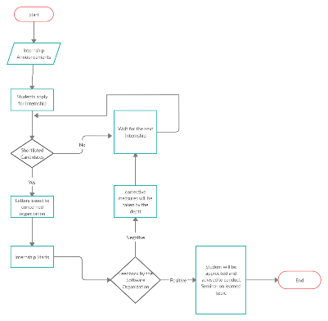
INTERNSHIP PROCESS
- Internships announced by the department.
- Interested students apply for the internships.
- Students are shortlisted by the following parameters:
- Skillset
- Seniority
- CGPA
- Letters issued by the department to the concerned software organizations for the shortlisted students.
- Remaining students are kept in the queue and advised to wait for the next internships.
- Shortlisted students are facilitated by the department to start their internships.
- Sealed Feedback forms are sent to the organization for evaluation of performance of the internee. Internship supervisors are advised to fill-in the form and send the same to the department.
- Upon receiving positive feedback, department advises the internee to conduct the seminar on learned skills.
- Upon receiving negative feedback, class advisors are advised to have a meet-up with the student. Student is suggested to work upon their weaknesses. The student is kept in the queue for the next internship in the same organization.
1.
2.
3.
4.
5.
6.
7.
8.
9.

